**UNIT TESTING**

**Unit test**: To test a functionality independently if its working or not.

**UNIT TEST STRUCTURE:**

* Arrange- Act- Assert (AAA)

**Arrange**: This is the first step of a unit test application. Here we will do the necessary setup of the test. For example, to perform the test we need to create an object of the targeted class or dummy variables, if necessary, then we need to create mock objects and other variable initialization, something like this.  
  
**Act**: This is the middle step of a unit step application. In this step we will execute the test. Basically, we will call the targeted function in this step using the object that we created in the previous step.  
  
**Assert**: This is the last step of a unit test application. In this step we will check and verify the returned result with expected results.

Ex.   //Arrange test

            testClass objtest = new testClass();

            Boolean result;

           //Act test

            result = objtest.testFunction();

           //Assert test

            Assert.AreEqual(true, result);

**JASMINE:** It is a framework for unit testing.

**KARMA:** It is a tool which causes the test to be executed. It launches the browser and then make browser test your code and return the test result.

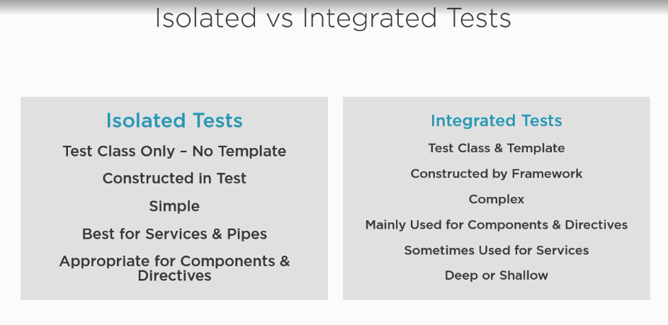

**INTEGRATED TEST:**

**FIXTURE:** It is a wrapper around the component which provide extra features with component.